CVD Prevention Programme - Guide to locating the TPP supporting resources.

  - How to locate the Referral Form and GP Practice invite letter:
- Logon to SystmOne
- Select >>> Setup >>> Referral & Letters >>> Word Letter Templates
- Click on the folder By Category
- Click on BSOL CCG Letter Templates
- Click on the folder called Referral Forms CVD Prevention Programme
- Here you can access the following documents:
  - CVD Prevention Programme Referral Form (Momenta v1) TPP
  - CVD PP Invite letter from GP Practice v1.2 TPP
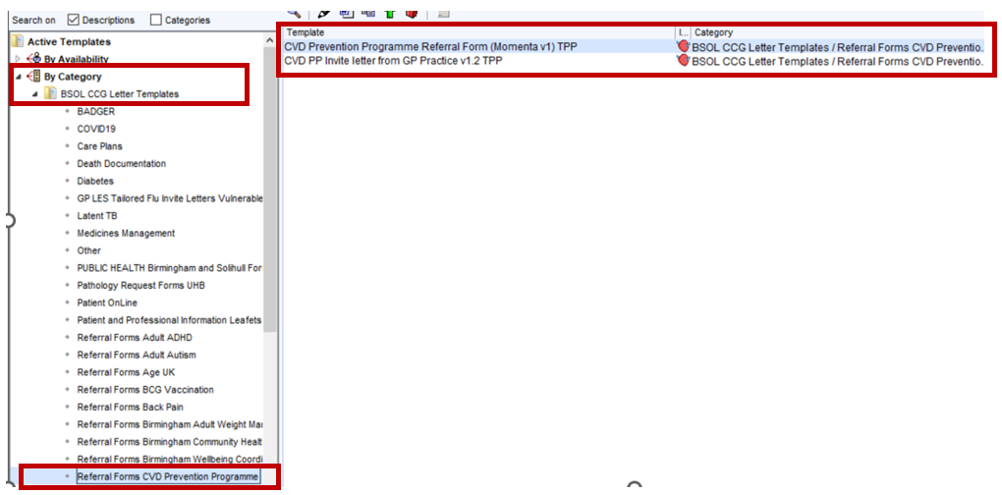
  - How to locate the eligible patient searches:
- Logon to SystmOne
- Select >>> Reporting >>> Clinical Reporting
- Click on the folder By Owner
- Click on NHS Birmingham & Solihull
- Click on CVD PP to access the searches.
