CVD Prevention Programme - Guide to EMIS supporting resources.

Once the EMIS resources have been imported onto your system, you can search for them to locate where they are stored within EMIS.

  - Eligible patient searches:
- Logon to EMIS
- Select >>> Reporting >>> Population Reporting
- Click on CVD Prevention Programme folder to access the searches.
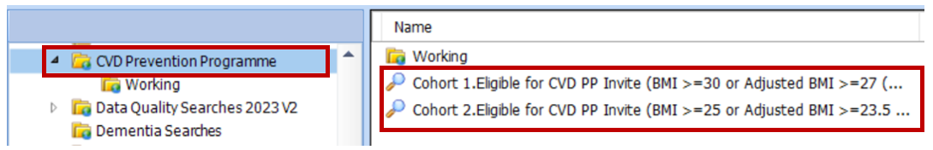

  - Referral Form and GP Practice invite letter:
- Logon to EMIS
- Open the patients record
- Click on Add >>> Document >>> Create Letter
- Click on the magnifying glass icon to search
- Type in the search box and type CVD and click Ok
- Here you can access the following documents:
  - CVD Prevention Programme Referral Form (Momenta v1)
  - CVD PP Invite letter from GP Practice v1.2
